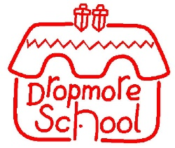 | GOVERNING BOARD  Meetings and Attendance  2024-2025 |  | CDPM 16.10.24 | FBP 13.11.25 | Full Governing Board 20.11.25 | CDPM 27.02.25 | FBP 05.03.25 | Full Governing Board 24.03.25 | CDPM | FBP | Full Governing Board
Governor |  | Governor Type
Mr Tim Wicks |  | Co-opted Governor | p | p | p | p | p | p
Fiona Greenfield |  | Co-opted Governor | p | p | p |  |  | p | p
Mrs Nicky Waugh |  | Co - Headteacher | p | p | p | p | p | p | p | p
Miss Amy Douglas |  | Co - Headteacher | p |  | p | p | p | p | p | P
Mrs Rochelle Fearon |  | Local Authority Governor | p |  | p | p |  | p | p | p
Mr Matt Hutchings |  | Co-opted Governor |  |  |  | p |  | p | p
Mrs Jag Lall |  | Parent Governor |  | p | p |  |  | p
Mrs Rebekah Fearon |  | Associate Member (no voting rights) |  |  |  |  |  |  | p
Mrs Lara Lawrence |  | Parent Governor | n/a | n/a | n/a | p | p | p | p
Mrs Holly Winter |  | Parent Governor | n/a | n/a | p |  | p | p |  | p
Mrs Charlotte Hemmings |  | Parent Governor | n/a | n/a | n/a | p |  | p | p

P = Present AP = Apologies received A = Absent n/a = not in position yet
CDPM = Curriculum Development and Pupils Matters / FBP = Finance, Buildings and Personnel

